PRESS STOP ! Tennent’s Whisky Oak

– lanseras 2 okt i Brewery Internationals monter.
- 330 ml flaska - 6%vol.

- Blending the past with the present, to create the future
Tennent Caledonian is Scotland’s oldest and most successful brewery.
With our rich history and heritage stretching back to 1556, we are in a unique position to create a beer combined with Scotland’s other national drink, whisky.
Brewed at our ancestral home in Glasgow, Tennent’s Beer Aged with Whisky Oak, draws on a lifetime’s commitment to brewing ales and lagers through the passion and expertise of our brewers.
Welcome to the family.
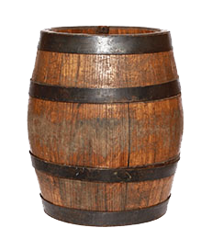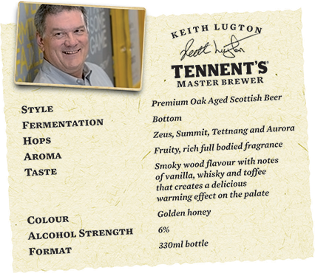

www.tennetswhiskybeer.com - www.brewery.se

