Motörhead Premium Dark Rum set to rock all 438 Systembolaget stores

It is impossible to imagine the world of modern music without acknowledging the impact of iconic UK band, Motörhead. Whether it’s metal, heavy rock, blues or even pop, Motörhead’s global influence can be found musically, visually and perhaps most telling, lyrically, with the ever unapologetic and ‘no-bull’ attitude. Apart from creating their own auditory tsunami of sound, Motörhead have also made their mark in the world of drinks, with their first Premium Dark Rum now available with a full distribution listing in all 438 Systembolaget stores in Sweden.

The Motörhead Premium Dark Rum is a product of the finest selection of Dominican Republic Caribbean Reserve Rums and has been aged for eight years in ex-bourbon barrels. The result is a smooth, dark brown rum which holds Motörhead’s boldness in every sip.

The band’s involvement in their beverage brand over the years has been significant, as it was their dream at last realised. Yvonne Wener, Business Manager at Brands For Fans explains: “While we miss them more than anything, we are thrilled to be able to contribute to the band’s legacy with the Motörhead Rum, which we hope the Motörhead fans and friends of rum will enjoy equally.”

Tasting notes:
Aromas of dried fruit, vanilla, brown sugar, arrack and dark chocolate. Full-bodied with notes of chocolate, arrack, vanilla, oak and nuts, with a medium and balanced sweet, spicy finish.

Serving suggestion:
- Live like lead singer Lemmy and mix a double shot of Motörhead Premium Dark Rum with cola.
- Dare to drink on the rocks as a sipping rum

Enjoy. Motörhead for Life.

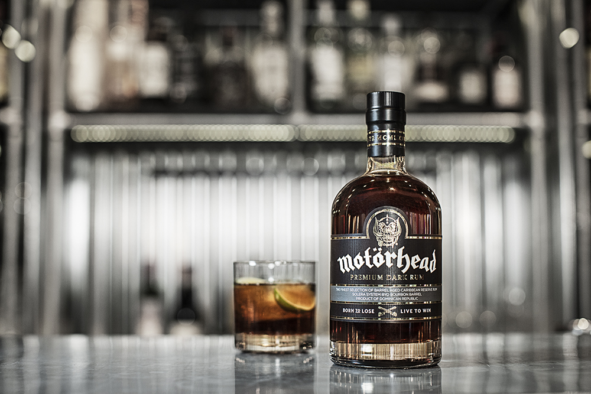
--------------------------------------------------

Motörhead Premium Dark Rum can be purchased at Systembolaget for 369:-
https://www.systembolaget.se/dryck/sprit/motorhead-1145001

Facebook: /motorheadspirits
About Motörhead Premium Dark Rum
ABV: 40%
Origin: Dominican Republic

